A screenshot of a cell phone

Description generated with very high confidence

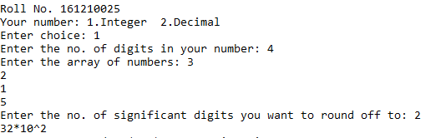

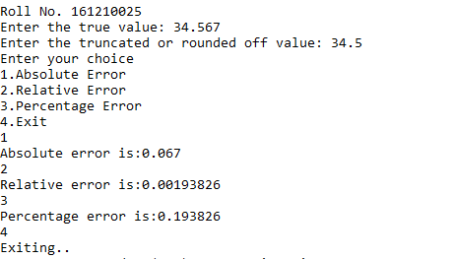

A screenshot of a cell phone

Description generated with high confidence

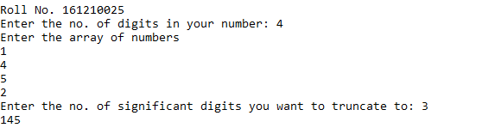

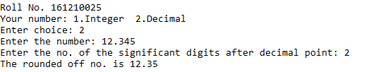

A screenshot of a cell phone

Description generated with high confidence

A screenshot of a cell phone

Description generated with high confidence